Credit Task 7.2 report

|  |  |
| --- | --- |
| Student Name | Lim Jia Lok |
| Student ID | 101212631 |

## SUB Task 7.2.1

#### Solution

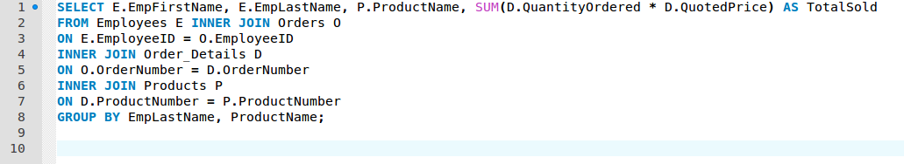

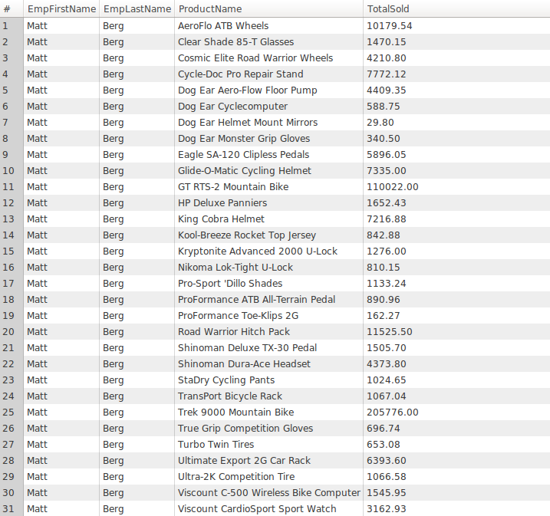

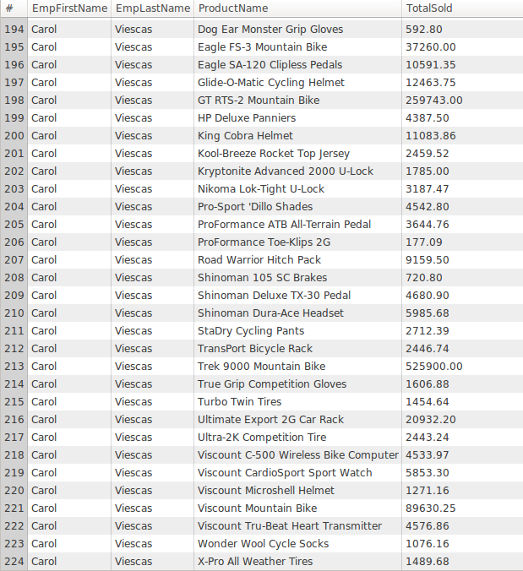

#### Comments/findings

…

(Where applicable)

## SUB Task 7.2.2

#### Solution

#### 

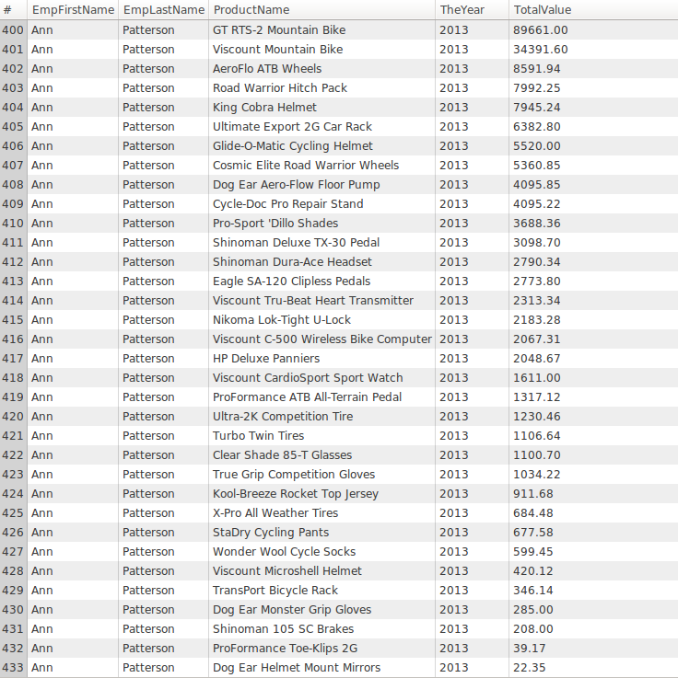

#### Comments/findings

…

(Where applicable)

## SUB Task 7.2.3 - Optional

#### Solution

….

#### Comments/findings

…

(Where applicable)